Here are the steps to placing an order

YOU provide | WE will
- Name  - Organisation  - Contact details  - Message | - acknowledge receipt of your message  - contact you to discuss details, provide clarification  - email to confirm any agreements / instructions / next steps

Step | Guidelines
1 | Choose report type | 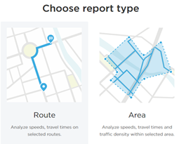
1.1 | IF…Route  …provide the start and end points AND the roads to be followed | 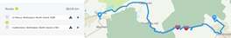
1.2 | IF…Area  …describe the polygon AND select the ONRC road classes | 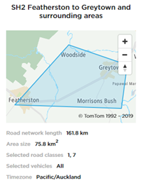
2 | Dates  …can be one date or a range of dates.  EG “1 May to 3 May in 2019”  Note there will be 1 answer for each time in “1 May to 3 May in 2019”  Note we may have data from up to 10 years ago. | 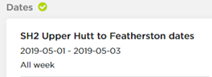
3 | Times  …choose up to 9 time ranges …which can vary …and be as small as 15 minutes  EG - 7-7.30, 8-8.15, 9-10 am  Note there will be 1 answer for each time across the date range. | 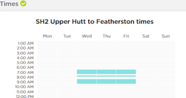
4 | Output  …please advise or discuss what you want. Options include:  …raw data (so you can do your own mapping and analysis)  …analysis | Raw data  Analysis  